## **CSP Boss**

CSP Boss is our self-service portal that lets you quickly and easily manage your Office 365 licensing, including adds, changes, and removals. For a tour, contact your Customer Success Manager.   
  
Login:

<https://Customer.cspboss.com>

**[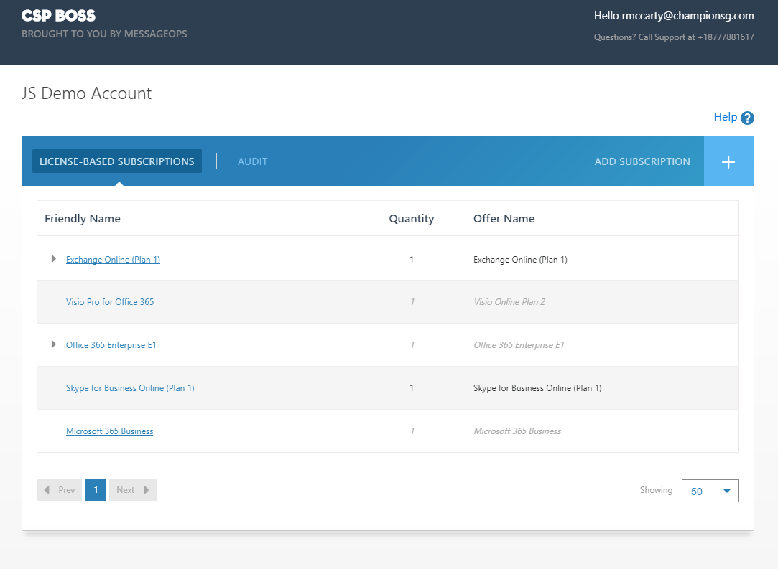](https://Customer.cspboss.com)**Use your Office 365 Global Admin (GA) credentials.

**Your dashboard displays a list of your current CSP subscriptions**

1. View a list of current CSP subscriptions with seat count.
2. Click on the triangle to view subscriptions Add-ons.
3. View the status of your subscription- gray means suspended.
4. Add new Office 365 CSP subscriptions.

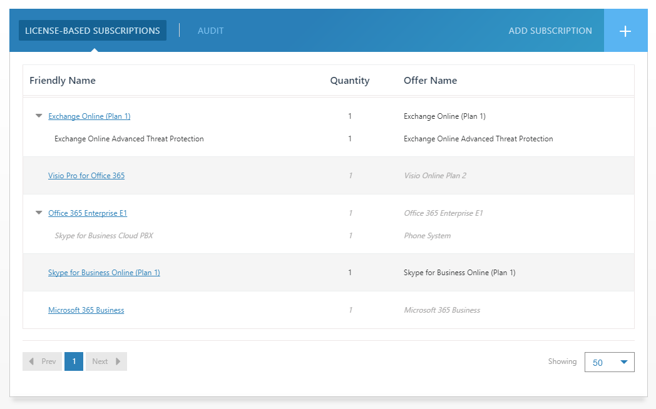

**Increase / Decrease quantities of your existing subscriptions**Click hyperlink into a subscription, this will open the Edit Subscription page where you can:

1. Increase the quantity of that subscription by entering the new amount in the New Quantity field.
2. Decrease the quantity of that subscription by entering the reduced amount in the New Quantity field.
3. Choose an Add-on subscription by entering a quantity under that subscription Add-on.
4. Suspend/cancel the subscription by clicking the Active button

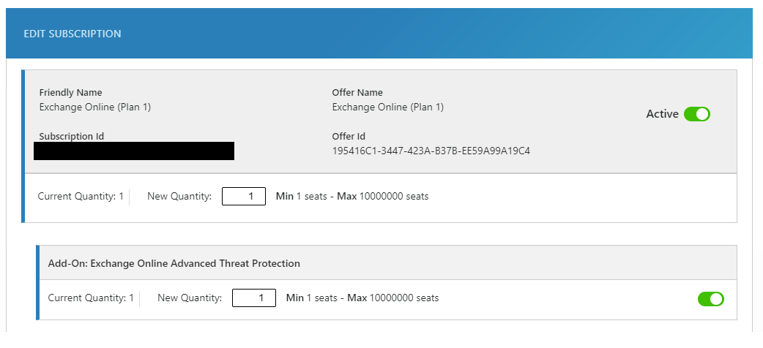

To proceed with any of the above actions, you **MUST** check the terms and conditions box first and click Update.

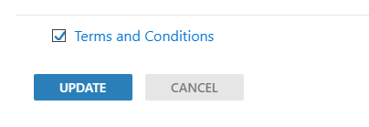

**Adding a new subscription that is not currently in your list**

1. From the home dashboard, click on the + sign next to Add Subscription to open the catalog.
2. Choose the license agreement type that you need by clicking on the title (Enterprise, Small Business, Government).
3. Check the box next to the license you need to add.
4. Enter the quantity needed for each license. (You can choose a license from each category before submitting)
5. Scroll to the bottom of the page. You **MUST** check the Terms and Conditions box before you can click submit.

